

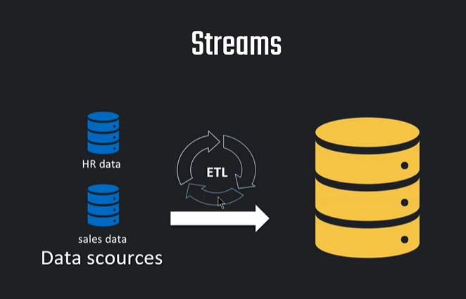
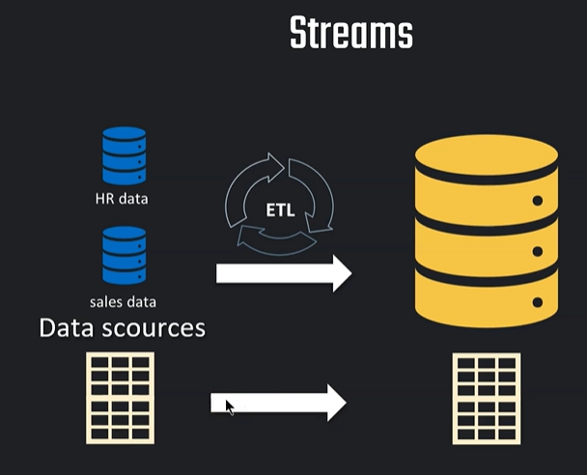

Only additional row needs to be loaded. not everything again
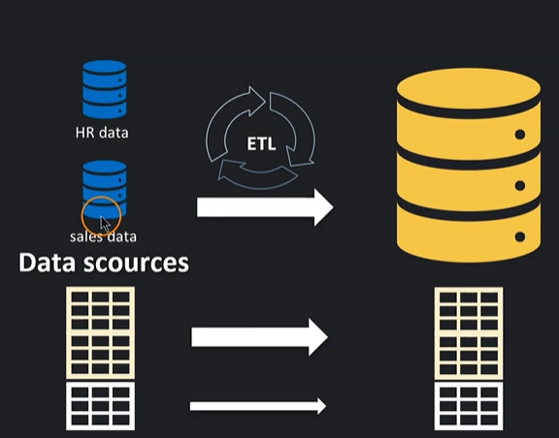

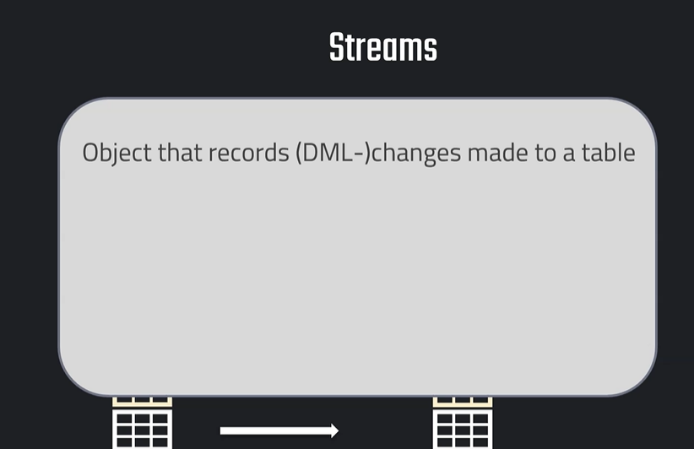
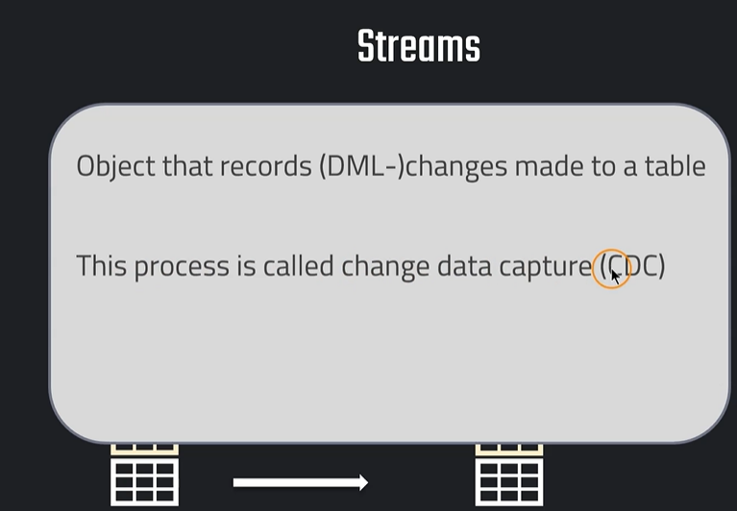
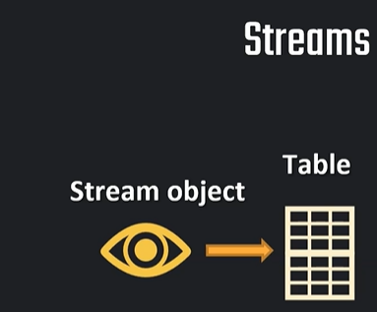



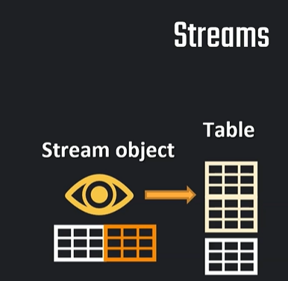

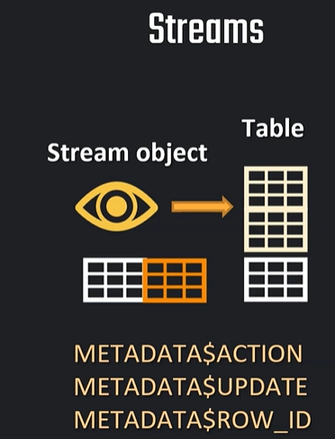

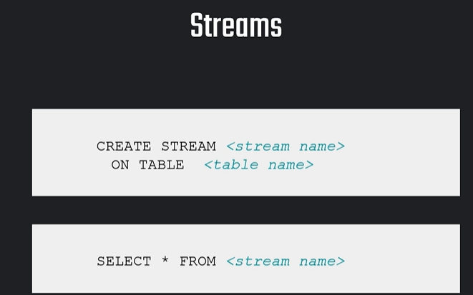

Stream is created on table
Once we capture the changes then that needs to be inserted in the target table.

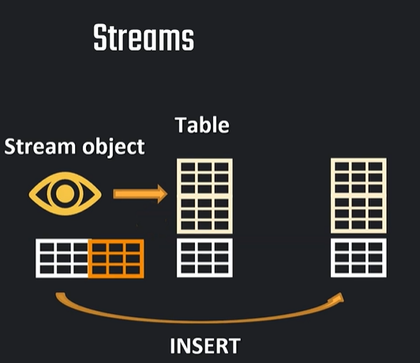

What is Stream in Snowflake?
A Stream in Snowflake is a Change Data Capture object.
It tracks changes happening in a table, such as:
INSERT
UPDATE
DELETE
A stream does not store full data separately. It stores metadata/offset information so that Snowflake can show what changed after the stream was created or last consumed. Snowflake streams are created on tables, views, dynamic tables, external tables, directory tables, etc.

Assume you have a table called CUSTOMERS.
Today the table has 1000 rows.
Tomorrow:
- 10 new customers are inserted
- 5 customers are updated
- 2 customers are deleted
Without Stream, you may need to compare yesterday’s data and today’s data manually.
With Stream, Snowflake can directly tell you:
These rows are inserted
These rows are updated
These rows are deleted
This is very useful for incremental loading, audit tracking, and ETL pipelines.

Real World Scenario
Scenario: Customer Data Sync
A company receives customer data from an application.
Main table:
CUSTOMERS_RAW
Final reporting table:
CUSTOMERS_TARGET
Requirement:
Whenever new customers are inserted or existing customers are updated in CUSTOMERS_RAW, only those changed records should be moved to CUSTOMERS_TARGET.
We should not reload the full table every time.

Step-by-Step Practical Example
Step 1: Create Database and Schema
CREATE OR REPLACE DATABASE STREAM_DEMO_DB;
CREATE OR REPLACE SCHEMA STREAM_DEMO_DB.PUBLIC;
USE DATABASE STREAM_DEMO_DB;
USE SCHEMA PUBLIC;

Step 2: Create Source Table
CREATE OR REPLACE TABLE CUSTOMERS_RAW
(
CUSTOMER_ID INT,
CUSTOMER_NAME STRING,
CITY STRING,
EMAIL STRING,
UPDATED_AT TIMESTAMP
);

Step 3: Insert Initial Data
INSERT INTO CUSTOMERS_RAW VALUES
(1, 'Arun', 'Chennai', 'arun@gmail.com', CURRENT_TIMESTAMP()),
(2, 'Priya', 'Bangalore', 'priya@gmail.com', CURRENT_TIMESTAMP()),
(3, 'Kumar', 'Coimbatore', 'kumar@gmail.com', CURRENT_TIMESTAMP());
Check data:
SELECT * FROM CUSTOMERS_RAW;

Step 4: Create Target Table
CREATE OR REPLACE TABLE CUSTOMERS_TARGET
(
CUSTOMER_ID INT,
CUSTOMER_NAME STRING,
CITY STRING,
EMAIL STRING,
UPDATED_AT TIMESTAMP
);
Insert initial data into target:
INSERT INTO CUSTOMERS_TARGET
SELECT * FROM CUSTOMERS_RAW;

Step 5: Create Stream on Source Table
CREATE OR REPLACE STREAM CUSTOMER_STREAM
ON TABLE CUSTOMERS_RAW;
This stream will start tracking future changes from CUSTOMERS_RAW.

Step 6: Check Stream
SELECT * FROM CUSTOMER_STREAM;
At this point, it may return no rows because no change happened after stream creation.

Step 7: Make Some Changes in Source Table
Insert New Customer
INSERT INTO CUSTOMERS_RAW VALUES
(4, 'Meena', 'Madurai', 'meena@gmail.com', CURRENT_TIMESTAMP());
Update Existing Customer
UPDATE CUSTOMERS_RAW
SET CITY = 'Hyderabad',
UPDATED_AT = CURRENT_TIMESTAMP()
WHERE CUSTOMER_ID = 2;
Delete One Customer
DELETE FROM CUSTOMERS_RAW
WHERE CUSTOMER_ID = 3;

Step 8: View Stream Data
SELECT * FROM CUSTOMER_STREAM;
You will see extra metadata columns:
METADATA$ACTION
METADATA$ISUPDATE
METADATA$ROW_ID
Meaning
Metadata Column | Meaning
METADATA$ACTION | Shows INSERT or DELETE
METADATA$ISUPDATE | TRUE if the row is part of an update
METADATA$ROW_ID | Unique internal row identifier
For an update, Snowflake may show two records:
DELETE old version
INSERT new version
That is how Snowflake represents update changes.

Step 9: Load Only Changed Data into Target Table
For insert and update records, use MERGE.
MERGE INTO CUSTOMERS_TARGET T
USING (
SELECT
CUSTOMER_ID,
CUSTOMER_NAME,
CITY,
EMAIL,
UPDATED_AT
FROM CUSTOMER_STREAM
WHERE METADATA$ACTION = 'INSERT'
) S
ON T.CUSTOMER_ID = S.CUSTOMER_ID
WHEN MATCHED THEN UPDATE SET
T.CUSTOMER_NAME = S.CUSTOMER_NAME,
T.CITY = S.CITY,
T.EMAIL = S.EMAIL,
T.UPDATED_AT = S.UPDATED_AT
WHEN NOT MATCHED THEN INSERT
(
CUSTOMER_ID,
CUSTOMER_NAME,
CITY,
EMAIL,
UPDATED_AT
)
VALUES
(
S.CUSTOMER_ID,
S.CUSTOMER_NAME,
S.CITY,
S.EMAIL,
S.UPDATED_AT
);

Important Point
Once stream data is consumed by a DML statement like MERGE, INSERT, or CREATE TABLE AS SELECT, the stream offset moves forward.
Now run:
SELECT * FROM CUSTOMER_STREAM;
It will become empty because the changes were already consumed.

Step 10: Handle Deleted Records
If you also want to delete from target when records are deleted from source:
DELETE FROM CUSTOMERS_TARGET T
USING CUSTOMER_STREAM S
WHERE T.CUSTOMER_ID = S.CUSTOMER_ID
AND S.METADATA$ACTION = 'DELETE'
AND S.METADATA$ISUPDATE = FALSE;
METADATA$ISUPDATE = FALSE is important because update also produces a delete record for the old version.

Types of Streams in Snowflake
1. Standard Stream
Tracks:
INSERT
UPDATE
DELETE
Example:
CREATE OR REPLACE STREAM CUSTOMER_STREAM
ON TABLE CUSTOMERS_RAW;
Use this when you want complete CDC tracking.

2. Append-Only Stream
Tracks only inserted rows.
CREATE OR REPLACE STREAM CUSTOMER_APPEND_STREAM
ON TABLE CUSTOMERS_RAW
APPEND_ONLY = TRUE;
Use this when your table only receives new rows, like:
sales transactions
log data
sensor data
clickstream data
Append-only streams can be more efficient because they ignore updates and deletes.

3. Insert-Only Stream
Used for external tables.
CREATE OR REPLACE STREAM EXT_STREAM
ON EXTERNAL TABLE MY_EXTERNAL_TABLE
INSERT_ONLY = TRUE;
Insert-only streams are mainly for external tables. Snowflake notes that INSERT_ONLY streams can only be created on external tables.

Stream Staleness
A stream can become stale if you do not consume it within the table’s data retention period.
For example:
Table retention = 1 day
Stream not consumed for many days
Old change history is no longer available
Stream becomes stale
Snowflake says a stream becomes stale when its offset falls outside the data retention period of the source object. Once stale, unconsumed change records are no longer accessible and the stream must be recreated.
Check streams:
SHOW STREAMS;

Stream + Task Real World Automation
In real projects, streams are usually used with Tasks.
Stream = identifies changed rows
Task = runs automatically on schedule
Example:
CREATE OR REPLACE TASK LOAD_CUSTOMER_CHANGES_TASK
WAREHOUSE = COMPUTE_WH
SCHEDULE = '5 MINUTE'
AS
MERGE INTO CUSTOMERS_TARGET T
USING (
SELECT
CUSTOMER_ID,
CUSTOMER_NAME,
CITY,
EMAIL,
UPDATED_AT
FROM CUSTOMER_STREAM
WHERE METADATA$ACTION = 'INSERT'
) S
ON T.CUSTOMER_ID = S.CUSTOMER_ID
WHEN MATCHED THEN UPDATE SET
T.CUSTOMER_NAME = S.CUSTOMER_NAME,
T.CITY = S.CITY,
T.EMAIL = S.EMAIL,
T.UPDATED_AT = S.UPDATED_AT
WHEN NOT MATCHED THEN INSERT
(
CUSTOMER_ID,
CUSTOMER_NAME,
CITY,
EMAIL,
UPDATED_AT
)
VALUES
(
S.CUSTOMER_ID,
S.CUSTOMER_NAME,
S.CITY,
S.EMAIL,
S.UPDATED_AT
);
Start task:
ALTER TASK LOAD_CUSTOMER_CHANGES_TASK RESUME;

Final Simple Explanation for Freshers
Table = Stores actual data
Stream = Watches the table and remembers what changed
Task = Runs the stream processing automatically
MERGE = Applies those changes into the final table
Real-time Example
Amazon order table receives new orders every minute.
Instead of loading the full order table again and again,
we create a stream.
The stream captures only new/changed orders.
A task runs every 5 minutes and moves only those changed orders
into the reporting table.
This saves:
Time
Warehouse cost
Processing effort
Manual comparison

